Software Design Document

Version 1.0

September 15, 2021

Restaurant Ordering System

Harsh Saglani

[hsaglani@umd.edu](mailto:hsaglani@umd.edu)

Submitted in partial fulfillment

of the requirements of

ENPM809W - Project Phase 1

# 

# 

# **Table of Contents**

**Table of Contents** **2**

**1. Introduction** **3**

1.1. Scope 3

1.2. Purpose 3

1.3. Definitions, Abbreviations and Acronyms 3

1.4. References 4

1.5. Overview 4

**2. Architecture** **5**

2.1. Overview 5

Figure: Client-Server Architecture Design 5

2.2. Advantages of Client Server Architecture 6

2.3. Disadvantages of Client Server Architecture 6

2.4. Overview of Security Concerns & Measures 6

2.4.1. The Server System 6

2.4.2. The Database 6

2.4.3. The User and Chef’s Tablets 6

2.4.4. Passwords 7

**3. Database Design** **7**

3.1. Database Overview 7

**4. Design Viewpoints** **9**

4.1. Introduction 9

4.2. Context Viewpoint 9

4.2.1. Block Diagram 9

4.4. Interaction Viewpoint 10

4.4.1. Sequence Diagram for chef 11

4.4.2. Sequence Diagram for user 12

4.4.3. Sequence Diagram for admin 13

4.5. State Dynamics Viewpoint 14

4.5.1. State Diagram 14

4.6. Behavioral Viewpoint 15

4.6.1 Activity Diagram 15

Figure: Activity Diagram for a food order 15

# **1. Introduction**

## ***1.1. Scope***

This project will be a web application software for ordering and reviewing food items of a restaurant. The system is designed to be a quick paced interface and help the customer decide and order the food for their meal. The ordering system will be completely automatic with almost zero interaction between the restaurant staff and the customers. The web application will help other customers in ordering food items from the restaurant by viewing previous customer ratings and reviews. In addition, all requirements documented in the SRS shall be implemented and addressed in the SDD.

## ***1.2. Purpose***

This document describes all the standards and design of the restaurant ordering system to be used by the developers to follow in the implementation phase. The SDD is an important reference not only for developers, but also for the testing programmers and editors of documentation. With the help of standards and specification described here, team members can be more efficient and successful in implementing the product

## ***1.3. Definitions, Abbreviations and Acronyms***

| ER Diagram | Entity Relationship Diagram |
| --- | --- |
| Block Diagram | A diagram showing in schematic form the general arrangement of the  parts or components of a complex system or process |
| Context Diagram | A diagram showing single high level process and its relationship with other entities |
| Architecture Diagram | A diagram which shows what is being built, what are the constraints and how entities interact with the system. |
| Intranet | It is a local restricted communications network |
| DB | Database |
| Sequence Diagram | An Interaction diagram which shows how and in which order operations are carried out |
| State Diagram | A diagram used to show different states in the system and some stimuli can lead to state change |
| Activity Diagram | A diagram which graphically shows the representation of a workflow of activities and actions. |

## ***1.4. References***

IEEE 1016-1998 - IEEE Recommended Practice for Software Design Descriptions

## ***1.5. Overview***

This subsection briefly describes each of the remaining sections in the document. The rest of the document is organized as follows:

The next section describes in detail how the database schema of the Restaurant Ordering System will be. It highlights the main entities of the database as well as the relations between them via the Entity Relationship Diagram.

The third section describes various viewpoints from the design perspective. It includes various diagrams including the block diagram,

# 

# **2. Architecture**

## 2.1. Overview

This section describes the system architecture of the Restaurant Ordering System. The architecture is a simple client-server architecture with some additional changes. Firstly, the system will not be available or published on the internet. The system will run on a local server and will be hosted on the restaurant’s intranet. Secondly, the system will be accessible by a web browser and via connecting to the local ip address of the server where the application will be hosted.

The users and chefs will access the system by using a tablet already connected to the system’s intranet network. Whereas the administrator will have direct access to the server as well as the database system.

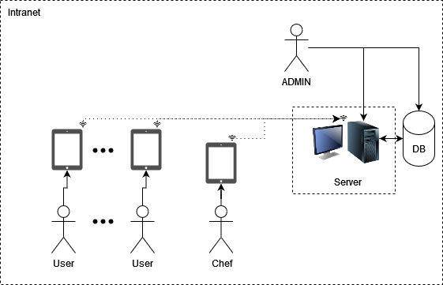

#### Figure: Client-Server Architecture Design

The intranet will consist of a wifi router which will make the application available to the users and chefs. The users and chefs will connect to the router via their tablets to access the application. The administrator can directly use the server system to get access to the application as well as the database. The server system can be directly connected to the router via a LAN cable. Depending on the size of the restaurant, the restaurant must set up additional repeaters so that the network connection is strong between all the devices.

## 2.2. Advantages of Client Server Architecture

1. Can handle multiple devices and requests simultaneously
2. The network is centralized
3. There will be only one system to secure
4. Can be scaled easily

## 2.3. Disadvantages of Client Server Architecture

1. If the server goes down, the whole system will not be functional.
2. A good server can be expensive to set up.
3. If any part of the network fails, a lot of disruption could occur.

## 2.4. Overview of Security Concerns & Measures

In this subsection we will talk about all the factors that affect the overall security of the application.

### 2.4.1. The Server System

The entire application lives on the system at the restaurant. Therefore it is extremely essential that only the administrator has access to that system. Nobody else should be allowed to access the system. The system should be kept in a safe location away from the reach of normal users. Regular copies of the system should be maintained. Recommended duration would be monthly if not weekly. The server should at all times be connected to the local network (intranet).

### 2.4.2. The Database

The restaurant can choose to put the database on the same computer as the server. This means that suggestions in section 2.4.1. should be carefully followed. Even if the database is on some other system, the same measures apply. However, if the restaurant wants, they can take daily backups of the database. Although weekly backups should suffice, unless they want to preserve each and every review of the past week in case of database failure or data loss.

### 2.4.3. The User and Chef’s Tablets

The user’s tablet should be connected to the router via wifi. The user should be able to access the restaurant system without any login, but the user must create a session by selecting the table number where the user will be ordering food to. The chefs, however, will need to login to access the orders placed by the users and to change the order statuses.

### 2.4.4. Passwords

All of the devices should be secured via strong passwords. Here’s a list of devices or applications from higher to lower priority which should be secured via a strong password.

1. The server’s desktop login
2. Database login
3. System login - Admin
4. Network login (to the router) - All tablets are connected via this.
5. System login - Chef
6. Tablet login

# **3. Database Design**

## 3.1. Database Overview

This section provides the translation of the informational model contained in the Software Requirements Specification (SRS) into a relational database. The relational database will be composed of tables. Each table is a series of columns which represent individual data elements. The data records in the table form the rows. Each table has a primary key. Tables are related to each other by embedding the primary key from one table into another as a foreign key to implement the relationship. Foreign keys enable the relational database management system to enforce referential integrity. Referential integrity ensures that no row in a “parent" table can be deleted if it is still referenced in a row of a "child" table.

Our database design consists of 6 tables namely Orders, Users, OrderMapping, Food, Ratings and logs. The OrderMapping table has two foreign keys which map to the order_id in the Orders table and food_id in the Food table. Similarly, the Ratings table has a foreign key food_id which maps to food_id in the Food table. This is how food items are linked to the orders and how ratings and reviews are mapped to the food items. The Logs table has a primary key log_id and is used for storing logs.

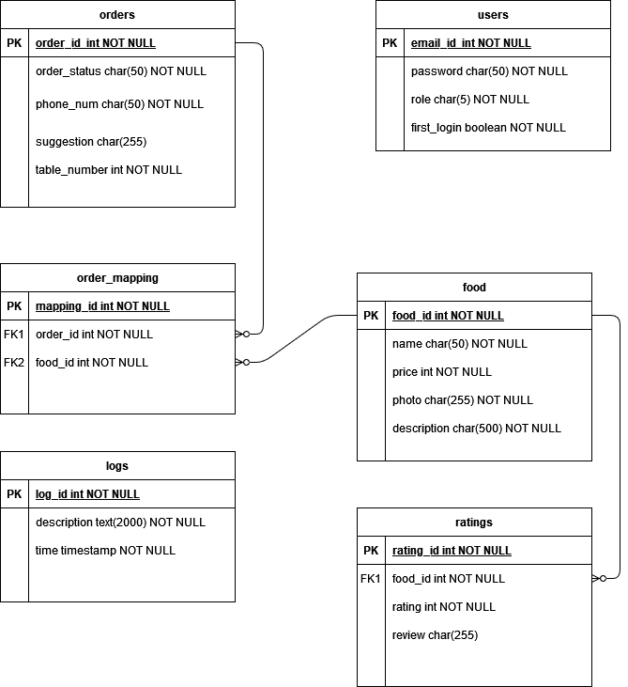

Figure 1 - ER Diagram

# **4. Design Viewpoints**

## ***4.1. Introduction***

This section describes various main design viewpoints of the Restaurant Ordering System along with some of the design concerns.

## ***4.2. Context Viewpoint***

This viewpoint of the Restaurant Ordering System illustrates the functions provided by the design subjects with reference to an explicit context. Functions, relationships, dependencies and interactions make up the services.

### **4.2.1. Block Diagram**

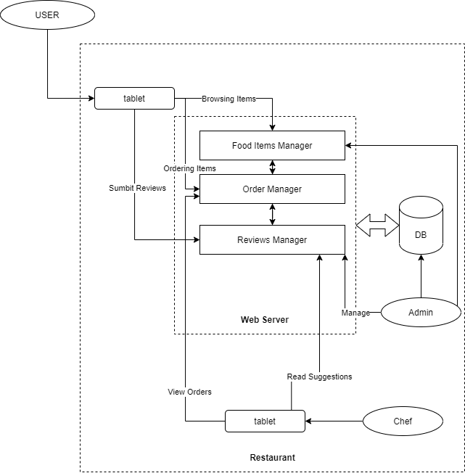

There are 3 main actors for the system. The untrusted “user” will have to use the restaurant’s tablet as an interface to get access to the restaurant’s web server. The other two users are chef and admin who are part of the restaurant. The admin will have direct access to the web server as well as the database.

**4.2.2. Context Diagram**

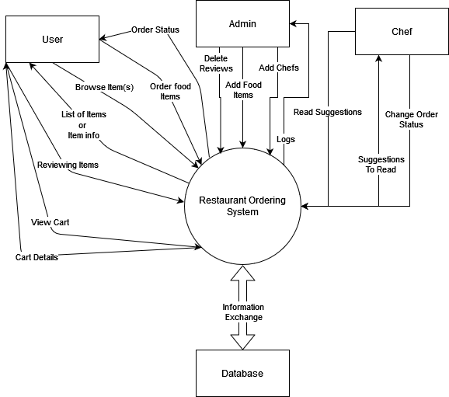

A context diagram shows a single high level process (in this case our system) and its interactions with entities (in this case user, admin, chef and the database).

## 4.4. Interaction Viewpoint

A sequence diagram explains the order of actions or processes in a time sequence. The blocks are objects or actors which handle data and communicate with each other. The small black dots indicate the start of a phase. They represent the start of one or more use cases. The vertical dotted lines represent the lifeline of the object/actor. The rectangular blocks show the time needed for an action to be completed. Arrows show the action taken by the objects as well as the direction of flow. An arrow with a filled arrowhead indicates a synchronous flow whereas an unfilled arrowhead indicates an asynchronous flow.

### 4.4.1. Sequence Diagram for chef

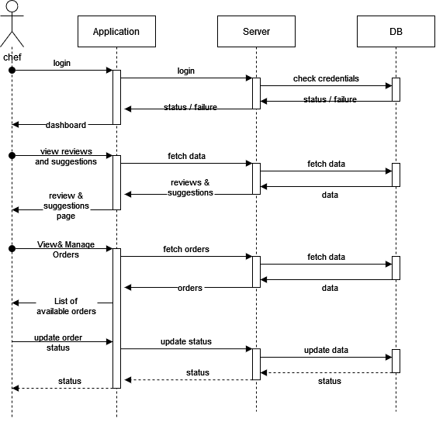

### 4.4.2. Sequence Diagram for user

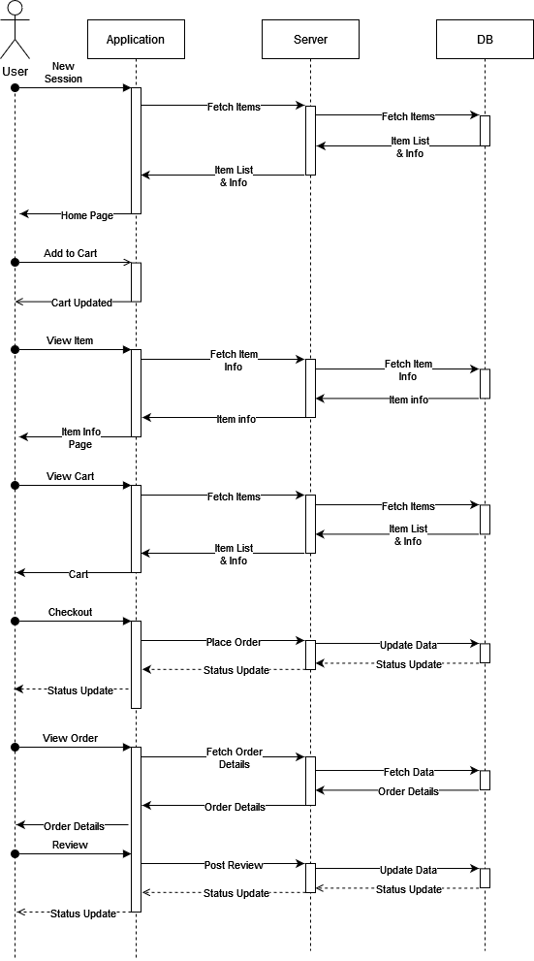

### 4.4.3. Sequence Diagram for admin

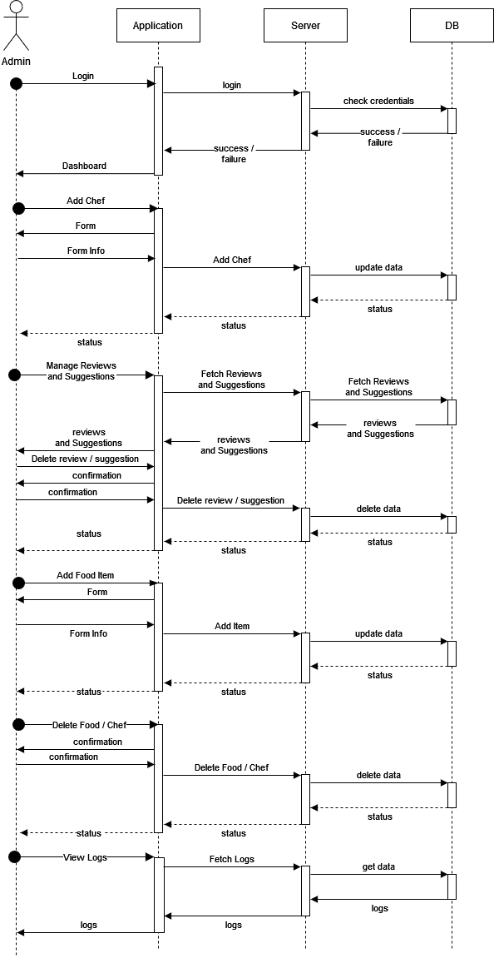

## 4.5. State Dynamics Viewpoint

### 4.5.1. State Diagram

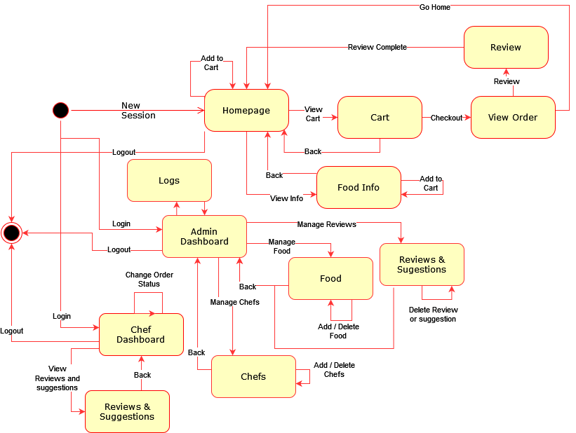

The state diagram explains how state changes in the system. Various states shown in the above diagram are one or more web pages. The black dot shows the starting point for the state and the black dot inside the circle shows the ending point. The lines show actions or navigation links via which the state change occurs. The yellow rounded rectangular blocks are states.

## 

## 4.6. Behavioral Viewpoint

### 4.6.1 Activity Diagram

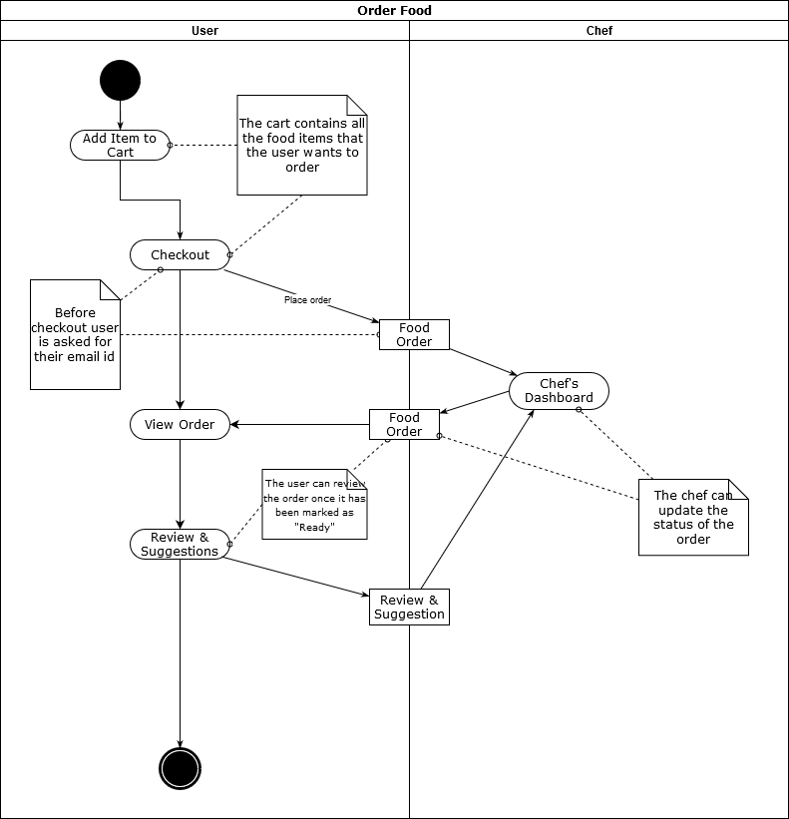

#### Figure: Activity Diagram for a food order

The activity diagram explains a workflow. In the diagram there are various components being used. Here is a list of components and what they mean -

1. A black dot - The starting point of a workflow.
2. A rounded rectangle - An action
3. A rectangle - An object
4. A note - Note
5. Straight line - Shows the flow from one point to another
6. Dotted line - usually connects two actions or actions with objects when there’s some extra explanation to be done.
7. A black dot inside a circle - End of the workflow